**VCU Icons for Click Commerce Lab Animals System**

**Background:**

Click Commerce is an electronic system that helps investigators fill out forms used to get approval for Lab Animal and Human Subject research projects. This means investigators around the university will log into the system and be presented with many different options for what types of actions they can do. Our goal is to have a set of icons that helps brand our site as unique to VCU, while at the same time being consistent across Lab Animals (IACUC), Human Subject (IRB), and possibly Grants (OSP) modules.

You can find copies of these icons at N:\VCUeRA\Lab Animals\Click Commerce\Icon Development

To begin with, Investigators will need to create the correct type of submission in the system.

**Default Create Icons:**

|  |  |  |
| --- | --- | --- |
| **Use** | **Default** | **New Icon Requirements** |
| Create new IRB Submission |  | Should read “New IRB Submission” |
| Create new IACUC Submission |  | Should read “New IACUC Submission” and NOT have a rabbit |
| Create new IACUC Amendment |  | Should read “New Amendment” |
| Create new IACUC Annual |  | Should read “New Annual” |

Example where these will be used…

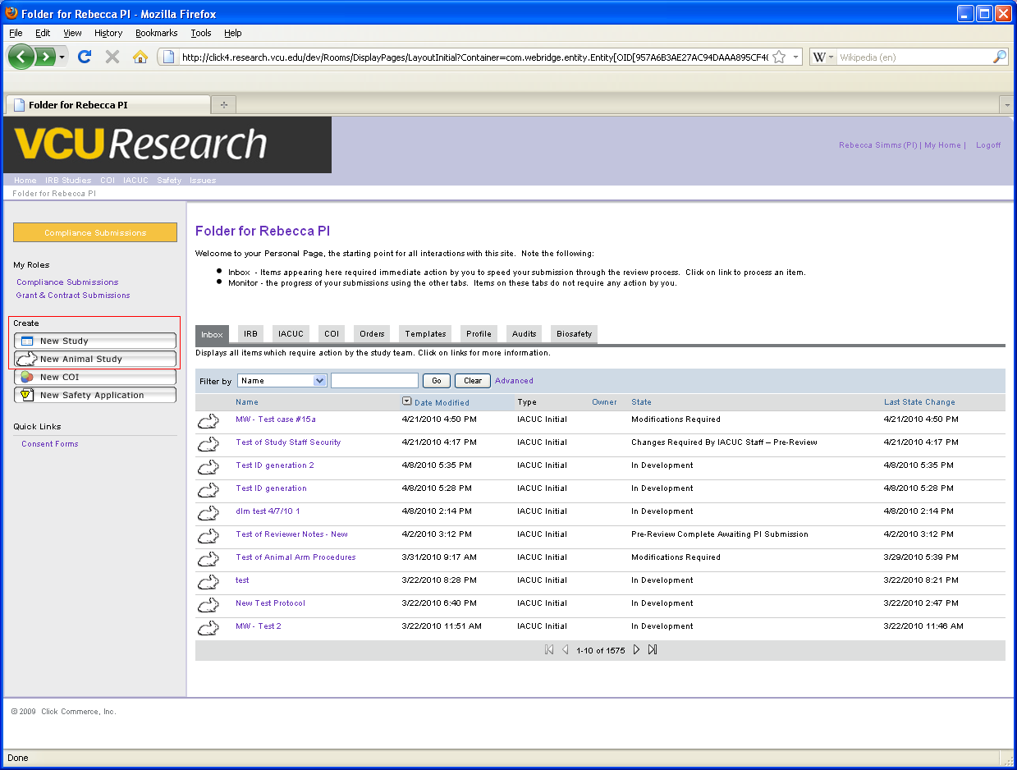

Once Investigators have created a submission, the system will give them various actions that they can take at certain times. We will need some icons that can be utilized across all the modules for this as well.

|  |  |  |
| --- | --- | --- |
| **Use** | **Default** | **New Icon Requirements** |
| Send email | None | Something that conveys that a message will be sent (i.e. letter/envelope/etc) |
| Log Public Comment | None | Something that conveys “taking a note” (i.e. pencil) |
| IACUC Chair Action Required |  | Something more descriptive that makes it clear the Chair is required |
| IACUC Board Member Action Required |  | Something more descriptive that makes it clear the Committee Member is required |
| Alert |  | More examples of this. Needs to convey warning somehow. |
| Study Staff Action Required |  | Something more descriptive |

Examples of where they are used…

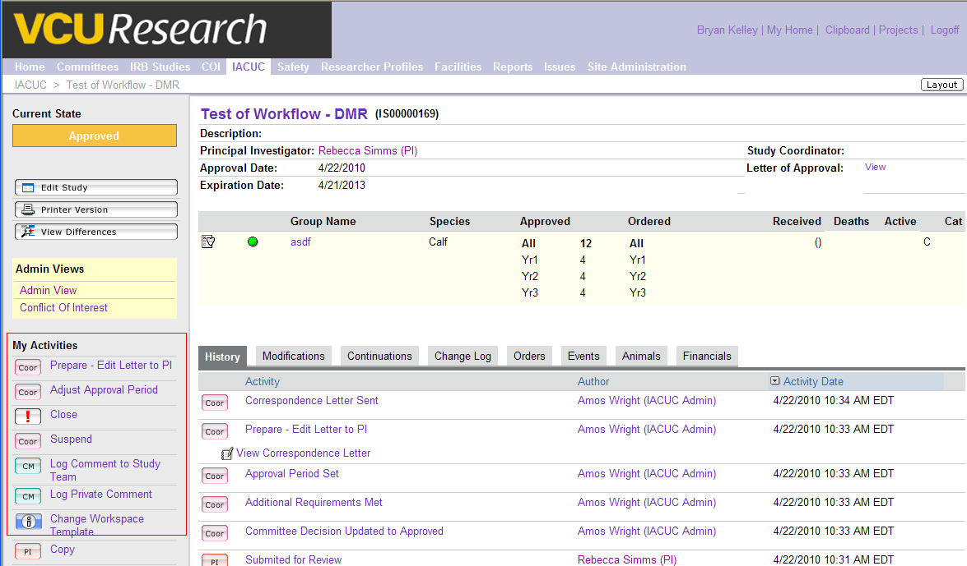

Below are other examples of icons currently in the system. These are fine as is, but if you feel they should be modified to better fit the theme you come up with, feel free to change them.

|  |  |  |
| --- | --- | --- |
| **Use** | **Default** | **New Icon Requirements** |
| Change templates |  | None. Change as you see fit (if necessary) |
| Action is required by Principle Investigator |  | None. Change as you see fit (if necessary) |
| Action is required by IACUC Coordinator |  | None. Change as you see fit (if necessary) |
| Action is required by the Department Chair |  | None. Change as you see fit (if necessary) |
| Action is required by the VCU Veterinarian |  | None. Change as you see fit (if necessary) |
| Financial updates |  | None. Change as you see fit (if necessary) |
| Updates to study |  | None. Change as you see fit (if necessary) |
| Updates to study |  | None. Change as you see fit (if necessary) |

**Technical Specifications:**

Please create .gif files that are nearly the same size as those that are store in the directory. If they are a few pixels wider that would be fine; however all the action icons should be consistently the same size. The “create” icons can be larger; however they should also be the same size.